Vernacular Names: Small-leaved Mangrove | Scientific Name: Lumnitzera racemosa Willd.
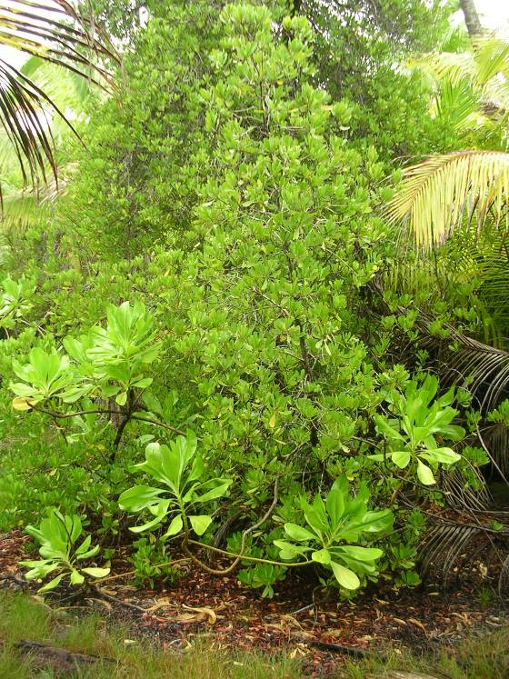 | 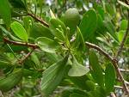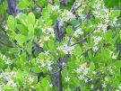  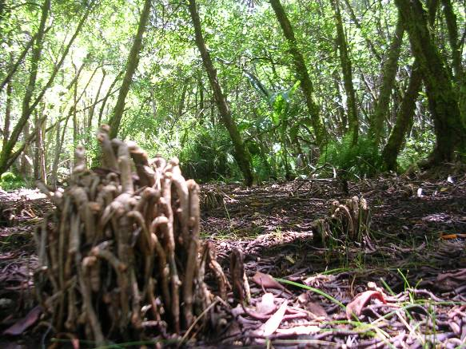
Full tree form (Scavvy in foreground) | Details of leaf, flower, fruit & breather roots
Native or Introduced: Native

Description: Leaves are succulent and small (up to 4cm length, 2cm width). The shape is obovate (broadest above the middle of the leaf), the apex is rounded or emarginated (the indent in the tip of the leaf). Petiole is often absent (leaves are then sessile) and leaves have a serrated edge. Flowers are up to 1 cm length, exhibiting 5 small white petals. Fruit is fleshy and flattened while on the tree, but fibrous after floating in water. In areas where inundation still occurs, dense areas of breather roots develop above the ground beneath the canopy.

Habitat: Lumnitzera racemosa grows on the landward edge of periodically flooded areas. On Eagle Island it exhibits both shrub and tree forms.

Human uses: Main trunk provides a hard and durable timber. In the Maldives, timber is used for wooden house construction and sticks of lesser diameter are used for rafters on wooden roof houses. Larger wood is sometimes used in boat building. Stems are used for poling boats in shallow water. It is considered as excellent firewood and high quality charcoal.

Significance: Only known from Eagle, growing where the Barachois has become cut off from the sea. Frequently inundated from beneath by the fresh water lens rising. Supports a good ground cover of ferns and grasses.

Propagation: It prefers relatively less moist, well drained, sandy soil mixed with clay for better performance. It also prefers relatively higher ground level than other mangrove plants. Propagated from nursery-raised seedlings and wildlings. Mature fruits are brown in colour, easily collected from trees or gathered from ground. Fruits are sown in a slanting position in containers, keeping half of the fruit inside the mud. Fruits should be stored in wet condition for 3-5 days before sowing.

